MET CS555 A3 Term Project

1. Description
Find a dataset for a research problem of interest, here are some good websites for this

Kaggle Data Science Competitions: http://kaggle.com
UCI Machine Learning repository: http://archive.ics.uci.edu/ml/datasets.php
Google Cloud public data: https://console.cloud.google.com/marketplace/browse?filter=solution-type:dataset&_ga=2.265202890.490000482.1586060190-1118401016.1586060190&pli=1

Describe a research scenario and specify a research question based on data analytic methods that we learned in our class, for example methods like, one and two sample means, t-test, correlation tests, simple and multiple linear regression, ANOVA and ANCOVA, one and two-Sample Tests for Proportions and logistic regression.

Clean up your data and reduce it to no more than 2000 observations if your data set is large.

2. Research Scenario Description (no more than 200 words)
Describe your research scenario in no more than 200 words. This is a general description of the use case. Similar to our class examples, we first describe the overall scenario and then we specify a specific research question based on it.

Many studies through the years have shown a positive link between moderate red wine drinking and good heart health. Recently, a review reported that drinking red wine is linked with a lower risk of coronary heart disease, which is a leading cause of disease and death in the United States. More and more families are choosing to buy red wine. In this project, we will focus on the red variants of the Portuguese "Vinho Verde" wine as the research object to discuss what makes this wine bad, okay or good quality.

3. Describe the data set (no more than 200 words)
Describe briefly the data set. Describe each of the columns of the data set that are used in your analysis. Clean up your data before usage (e.g. asses and remove outliers, perform any necessary transformations, ensure assumptions of your analysis are met). Remove unused columns. If possible, provide a link to the main data set source.

This dataset is related to red variants of the Portuguese "Vinho Verde" wine. With total of 1599 observations.
This dataset consists of 12 variables:
Input variables (based on physicochemical tests):
1 - fixed acidity
2 - volatile acidity
3 - citric acid
4 - residual sugar
5 - chlorides
6 - free sulfur dioxide
7 - total sulfur dioxide
8 - density
9 - pH
10 - sulphates
11 - alcohol
Output variable (based on sensory data):
12 - quality (score between 0 and 10)

Link: https://www.kaggle.com/uciml/red-wine-quality-cortez-et-al-2009

4. Research Question (no more than 100 words)
Describe briefly in one or two sentences the main research question. This is similar to the last sentence of our class examples.

The first 11 are objective variables involving chemical measurement. The 12th dimension, quality, is the variable we're trying to predict. We would like to know which variable is the best fit to predict the wine quality?

5. State Your Conclusion (no more than 100 words)
State the conclusion so that a non-statistician can understand.

From our research, the percent alcohol content of the wine is the best variable to predict the wine quality. When the wine’s quality output is <= 4, the wine is in bad quality; when the wine’s quality output is 5|6, the wine is in okay quality; when the wine’s quality output is >= 7, the wine is in good quality.

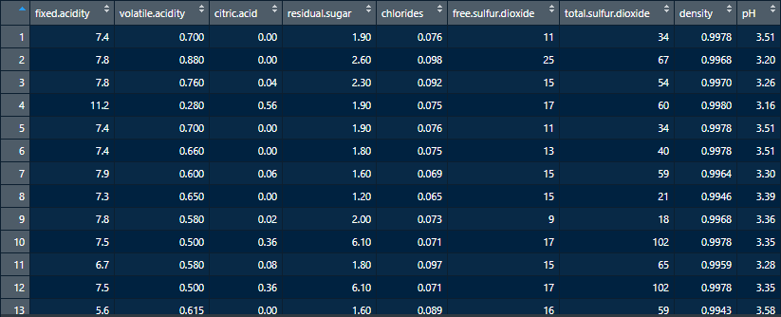
The 12th dimension, quality, is the variable we're trying to predict
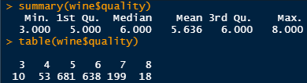
Try to use all the other variables instead of quality as input and do a linear regression.
It’s bit hard to tell. Next…
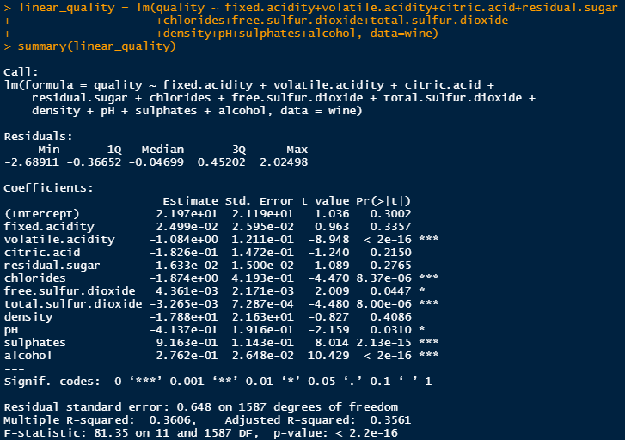
Use a correlogram, which reflects pairwise correlations
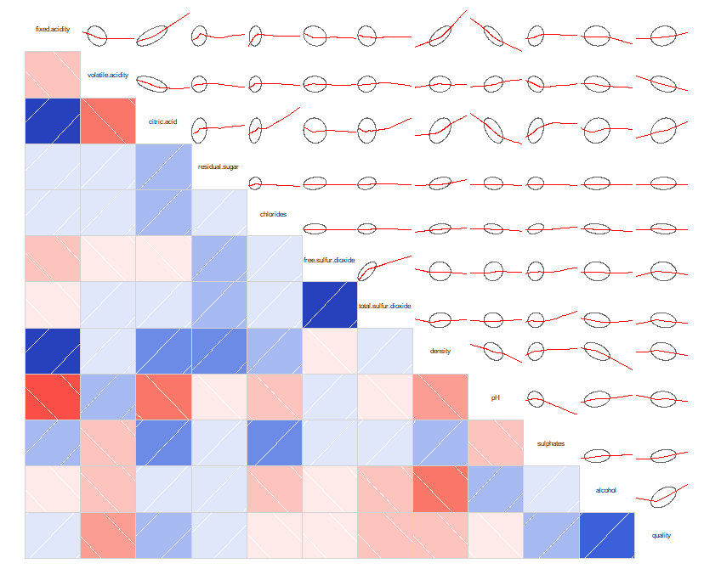
We're trying to predict quality, so we care about the final row and column in order to choose our variables. We may wish to look elsewhere in the matrix, too, to make sure that we're not picking independent variables that are quite correlated: for example, the free.sulphur.dioxide and total.sulfur.dioxide have extremely strong correlation, so we would not want to use both variables in a simplified model.
Try Single-variable linear regression with the strongest correlation: alcohol
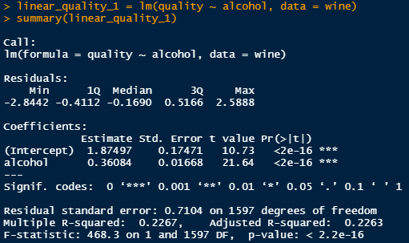
Our residual is worse than using all variables. The more variables, the better the fit-but this does not mean that it must be a better model.
Try Four-variable linear regression, using the variables: alcohol, volatile.acidity, citric.acid, and sulphates
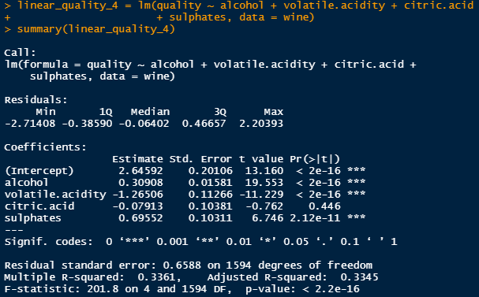
Visualizing the fits
One thing we are interested in is how well these models perform against each other. For each of these fits, we can get the residuals, and we can compare them to a certain dimension.
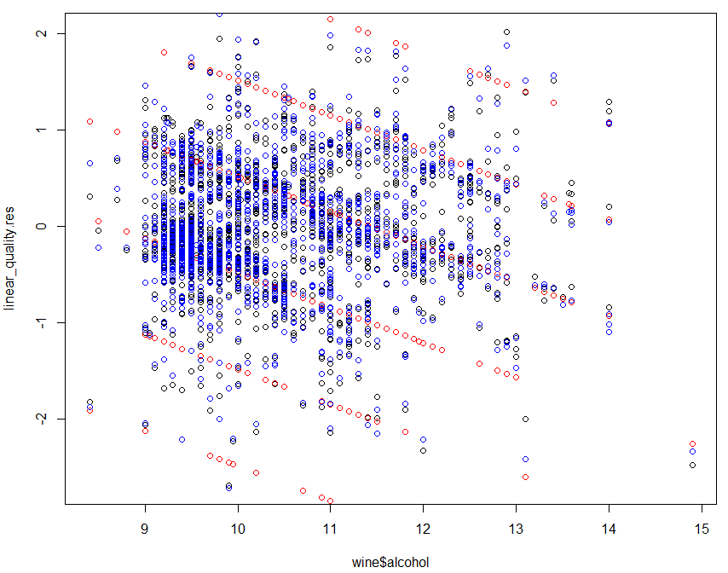
Try to generalized linear model
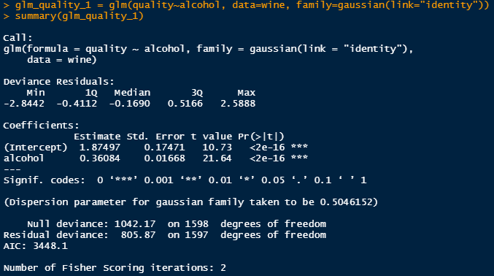
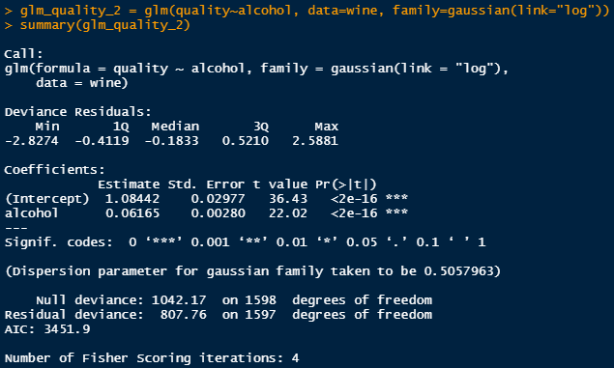
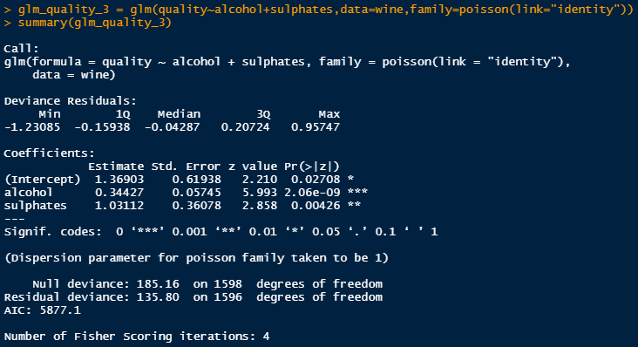
Residuals
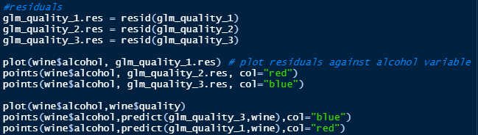
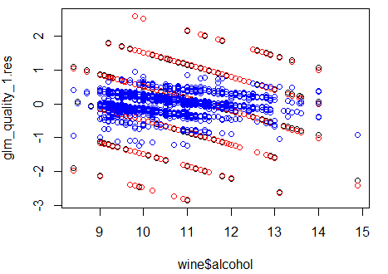
What the data look like versus the fitted models
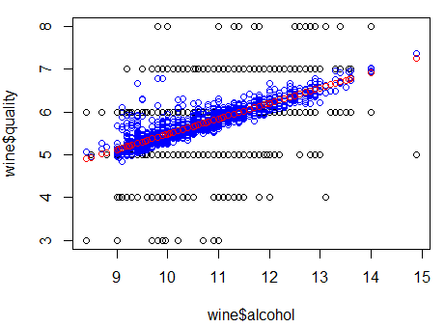
Classification

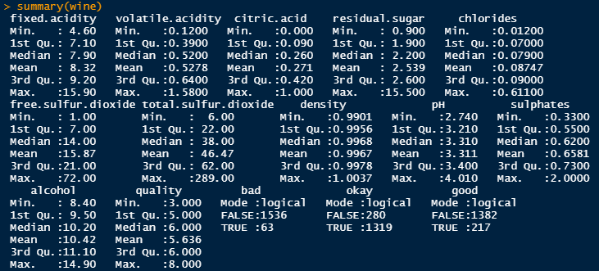
From the 1599 wine observations, there are 63 bottles of wine in bad quality, 1319 bottles of wine inokay quality and 217 bottles of wine in good quality.

Solution Submission
- Fill up this word file and upload it.
- Upload your data set. This is the data set after cleaning (a small CSV file)
- Upload your R code as a file with name “project_<firstname>_<lastname>.R” or in Jupyter notebook or R markdown

Grading will be done based on
- Originality of selected data set and data analysis approach
- Data Preparation and cleanup
- General Correctness of data analysis
- Quality of your R code and output results
- Correct final conclusion

